# Rail Enhancement Fund: Corridor Investment Scorecard

The Rail Enhancement Fund (REF) is a dedicated source of funding for capital improvements benefiting passenger and freight initiatives. This document outlines the process of and reason for evaluating the benefits of the Commonwealth’s investment in freight and passenger rail infrastructure.

## Purpose

Article X, Section 10 of the *Constitution of Virginia* indicates that the Commonwealth can only make internal improvements with state parks and the state highway system. Investment in rail infrastructure is not explicitly included in this article and, therefore, it has been ruled that any investment of Commonwealth funds in rail infrastructure must benefit the highway system (*Montgomery County v. Virginia DRPT*, 282 Va. 422,719). It is always important to highlight and summarize the benefits of any government program. However, the ruling in the *Montgomery v DRPT* case makes it critical to summarize and highlight the benefits of the REF program to the highways of Virginia.

In addition, in HB 1887, the 2015 General Assembly directed the Commonwealth Transportation Board (CTB) to “develop no later than December 1, 2015, a legislative proposal to revise the public benefit requirements of the Rail Enhancement Fund….” Section 427 of the Appropriations Act that same year directed the Secretary of Transportation and DRPT to summarize previous REF allocations, expenditures and transfers, as well as the long-term needs of the REF. The CTB, through its Rail Subcommittee, expanded the study to include an equivalent consideration of program policy goals for the REF program. As a result, DRPT, in conjunction with the Rail Subcommittee and an open process of stakeholder engagement, is conducting administrative improvements to simplify the grant process and to enhance overall transparency and accountability of REF activities. This REF scorecard is one initiative that will create higher accountability and transparency for the REF program.

## Process

To complete a vision of enhancing and expanding freight and passenger rail in Virginia, this Rail Enhancement scorecard will be created annually and provided to the CTB for their review and to assist with their assessment of the effects of the REF program.

1. **Step 1**—All REF grant agreements will include the requirement that grantees will provide data annually to DRPT in order to effectively and accurately complete the annual REF scorecard.
2. **Step 2**—DRPT will gather and analyze all grantee provided data, organizing the data by corridor and comparing both existing corridor-wide performance with the expected project benefits of each REF assisted project.
3. **Step 3**—DRPT will provide the REF scorecard to the CTB Rail Subcommittee annually, and will be available to discuss and dissect the report with the Rail Subcommittee members to ensure that the information is accurate and understandable.
4. **Step 4**—CTB Rail Subcommittee members and DRPT will be responsible for reviewing the scorecard information and updating the policies, procedures, and goals of the REF program according to the overall benefits to the highway system and performance of the railroads in Virginia.

## Scorecard Results

The following pages break down the REF program of investments and the resulting performance and benefits by strategic corridor within the Commonwealth of Virginia.

## Location of Strategic Rail Corridors in Virginia

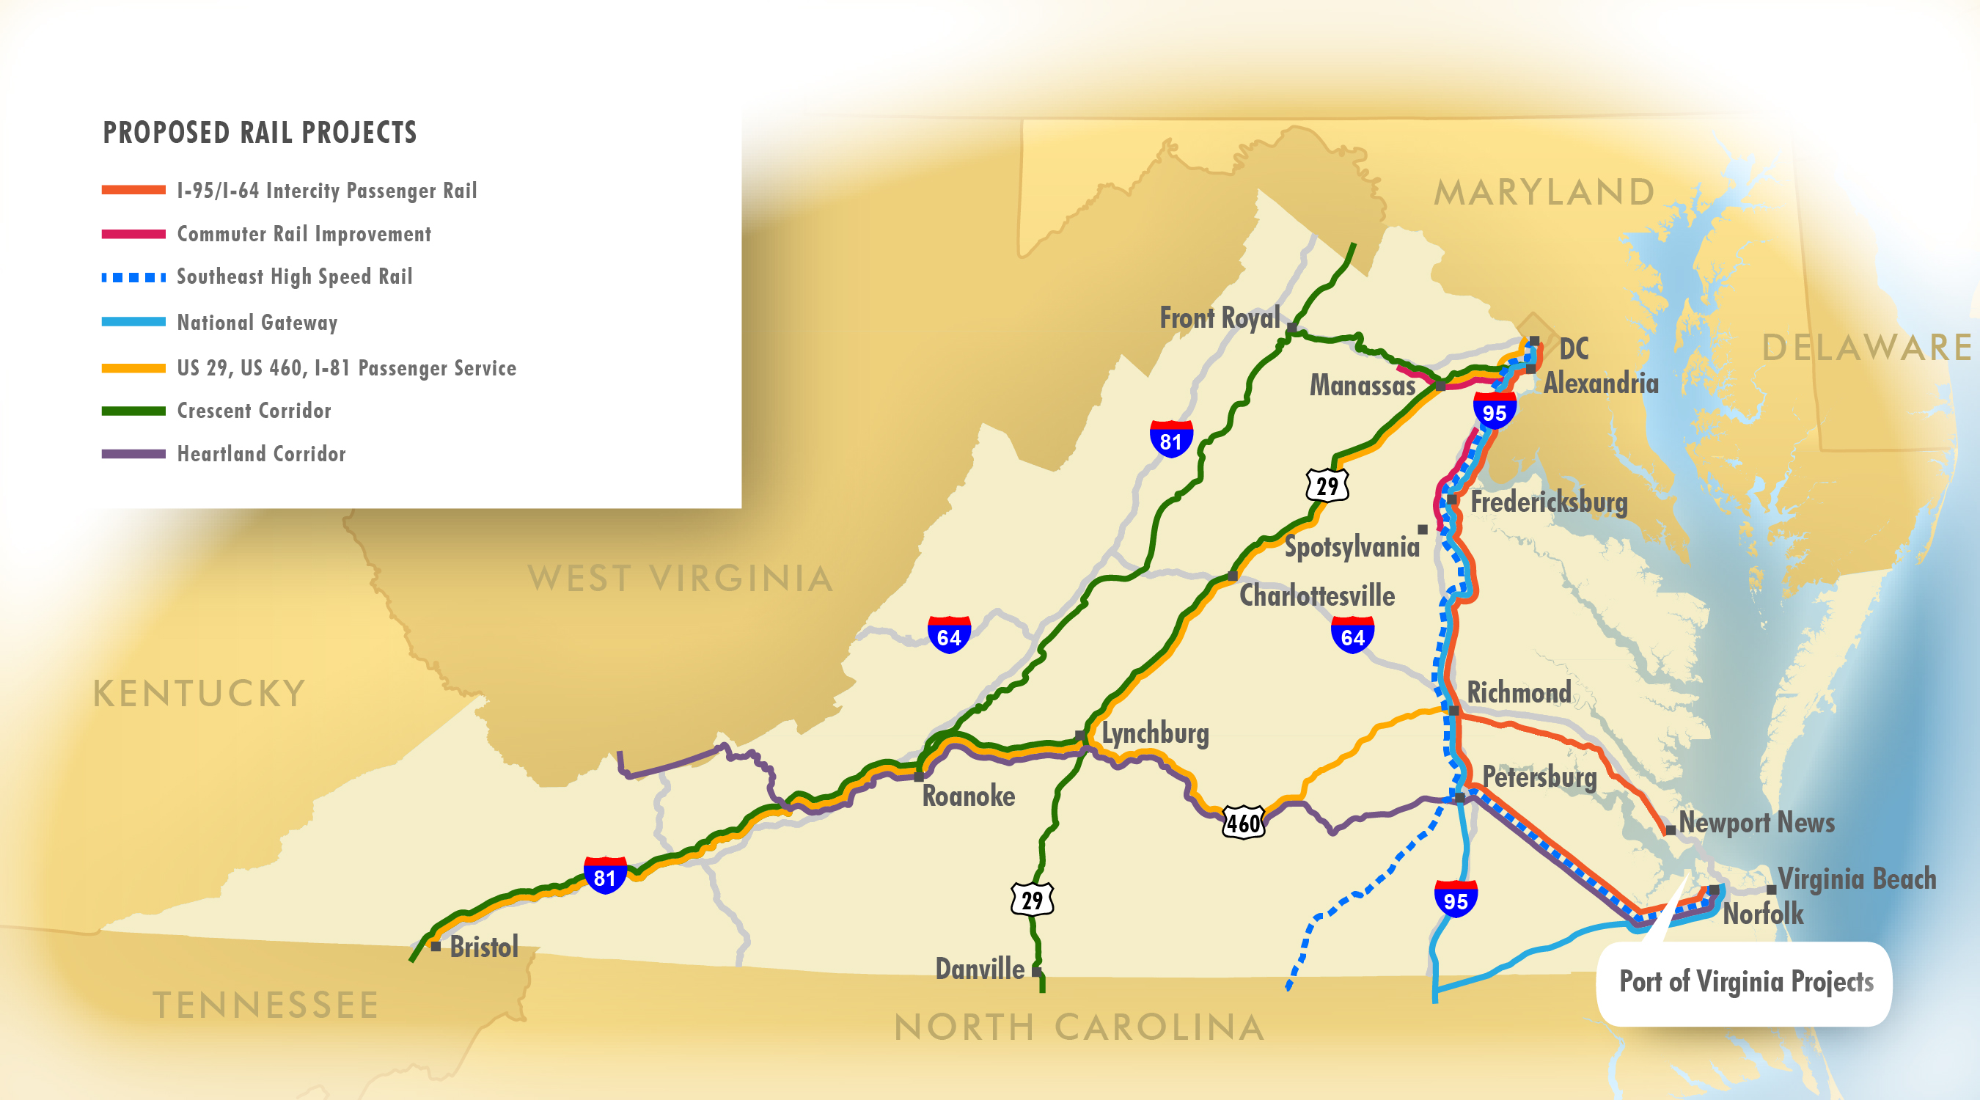

**Rail Corridors**

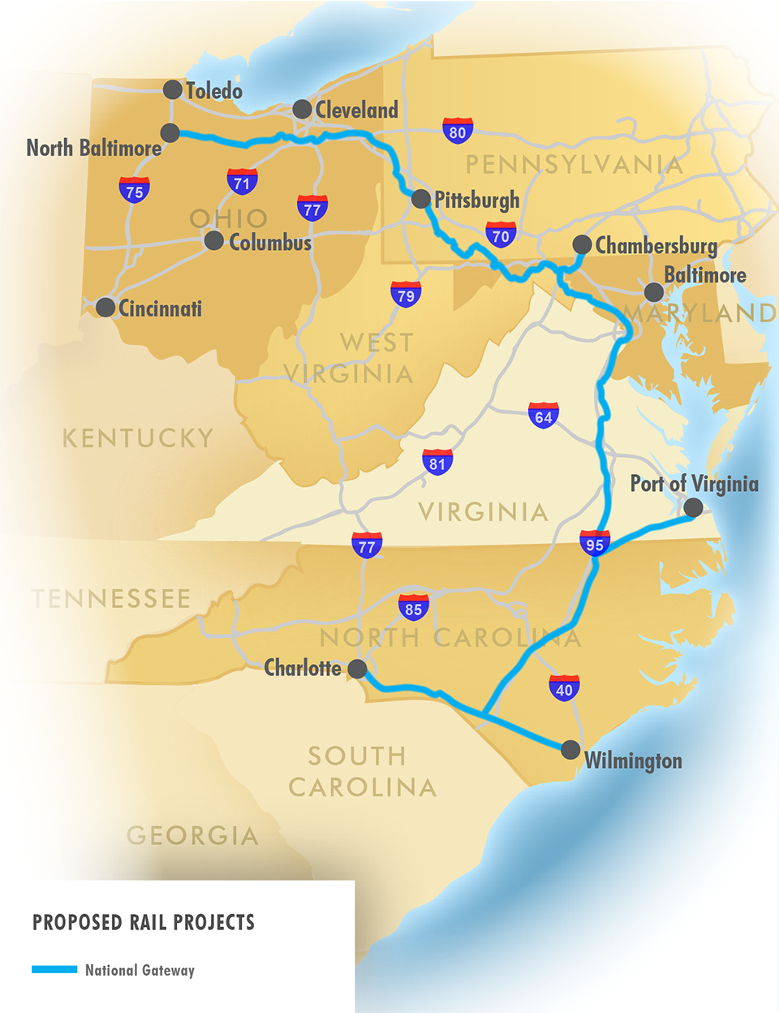National Gateway

Key facts

* The multi-state National Gateway Project extends from North Carolina to Ohio and parallels I‑95 through Virginia, with a con­nection to the Port of Virginia.
* The project plan focuses on improving clearances to enable double stack intermodal train opera­tions.
* Total REF funding includes $55 million, leveraging an additional $145 million of private and federal investment.

Projects

* **Acca Yard Improvements:** replace switches, signals and communications
  + $12,546,100 – PE and improvements
  + Total 3,462 hours of failure avoided
* **Double Stack Clearances:** clear overhead impediments
  + $3,595,900 – remove or modify bridges for double stack clearance
  + Total 115,000 additional rail cars
* **Kilby Support Yard:** rehabilitate and increase capacity at the support yard
  + $11,431,980 – PE and construction
  + Total 771,500 additional rail cars
* **Virginia Avenue Tunnel:** add second main line and double stack clearance
  + $24,001,100 – PE and construction
  + Total 771,500 additional rail cars
* **Branchville Siding Extension:** construct a siding on the Portsmouth Subdivision
  + $6,020,000 – PE and construction
  + Total 37,725 additional rail cars

105

|  |  |  |
| --- | --- | --- |
| Category | Benefit | Description |
| Congestion Cost | $230 M | Improvement in highway congestion by shifting traffic to rail. Cost savings realized by reducing lost wages and gas consumption when sitting idle. |
| Environmental | $60 M | Benefit associated with the reduction in the level of CO2, VOCs, NOx and Particulate Matter due do highway traffic moving to rail. |
| Shipping Cost | $1,200 M | Cost savings realized by reducing the existing route length and/or switching shipping modes; long haul shipping costs are lower by rail. |
| Pavement Maintenance | $60 M | Reduced road ‘wear-and-tear’ and associated pavement maintenance costs due to the mode shift from highway to rail. |
| Accident Cost | $1,620 M | Reduction in highway accidents reduces emergency response and loss of life costs. |
| Economic | $6 M | Improved labor productivity attributable to increased productivity while traveling via rail. |
| Corridor Velocity |  |  |
| On-Time-Performance | 70% | 2015 average of all passenger trains that arrived within 15 minutes of their scheduled arrival. |

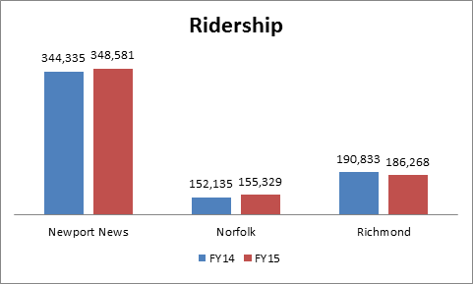

**Rail cars**